

Unit: CNS 2102:
Data Structures and Algorithms

Assignment 1- 4

Name: Ahmed Ahmed
Student No: 123456
Lecturer: Njoroge Kinyanjui

Date: Tuesday, May 27, 2025
Exercise 1: A program to reverse a string
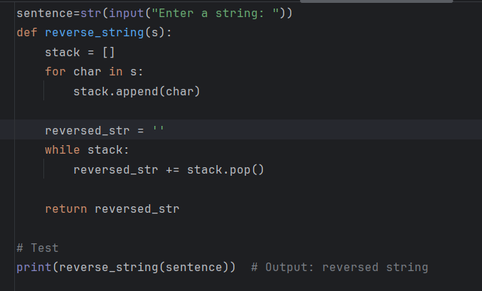
Output: Exercise 1
